To set up the Azure resources, install WordPress, configure it to use the Azure Database Server, and implement backup procedures, follow these steps:

1. **Create Azure Resources:**
   * **Azure Web Server:**
     + Navigate to the Azure Portal.
     + Click on "Create a resource" > "Web" > "Web App".

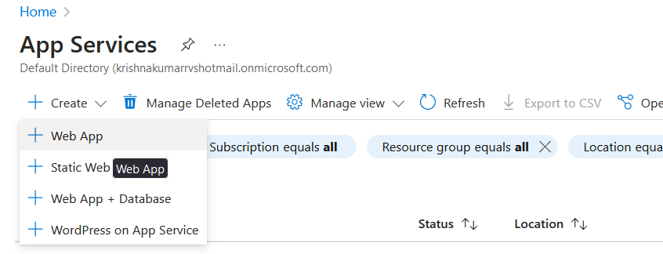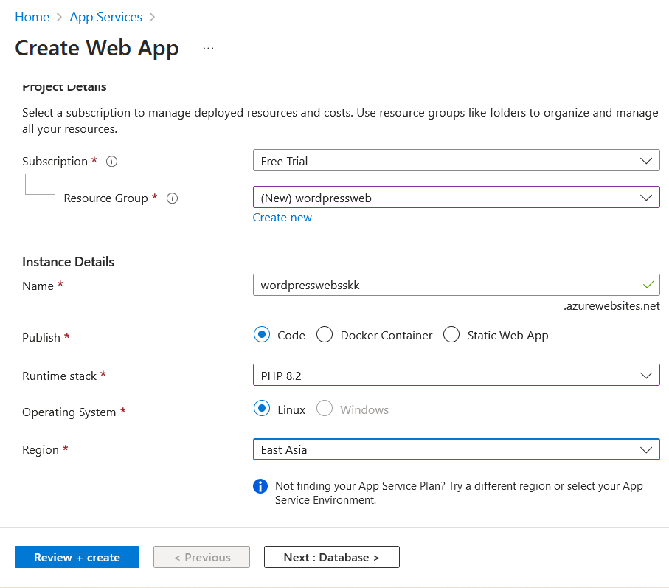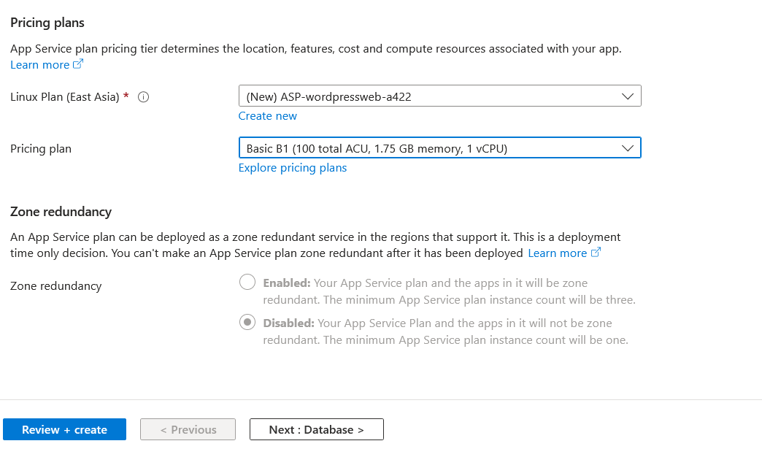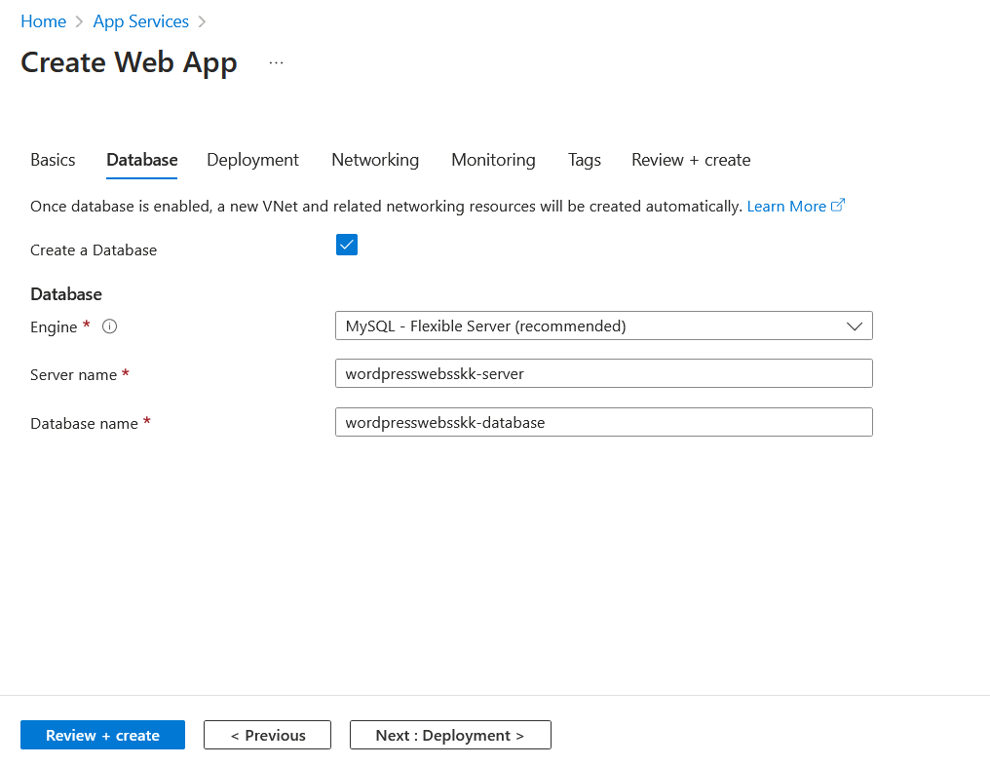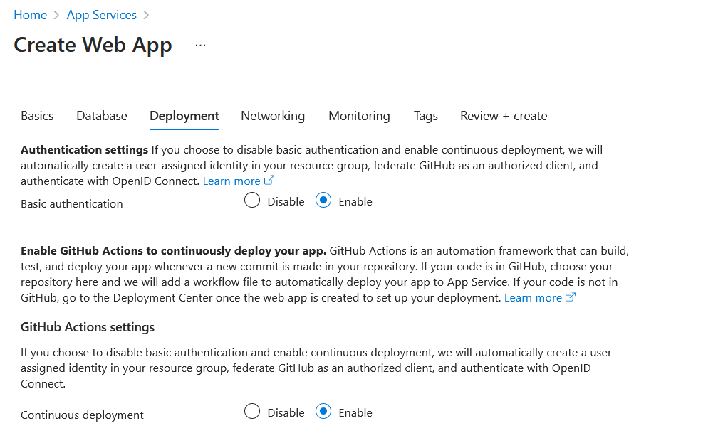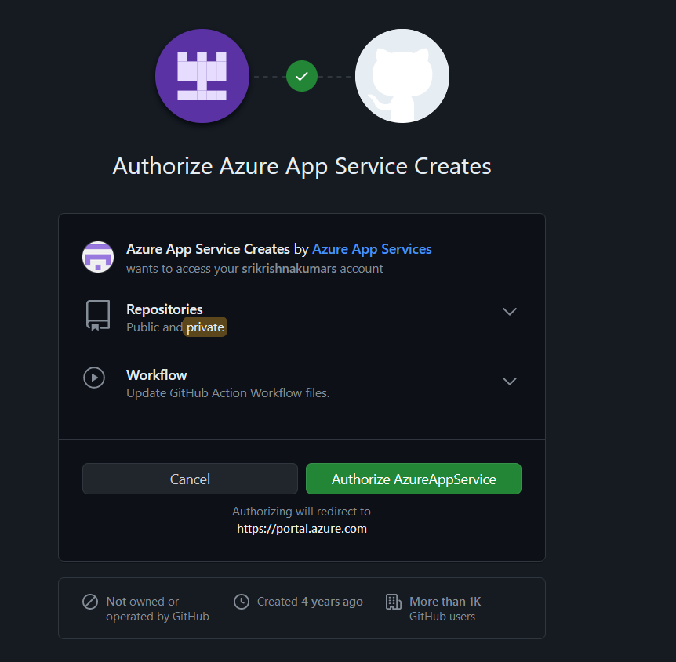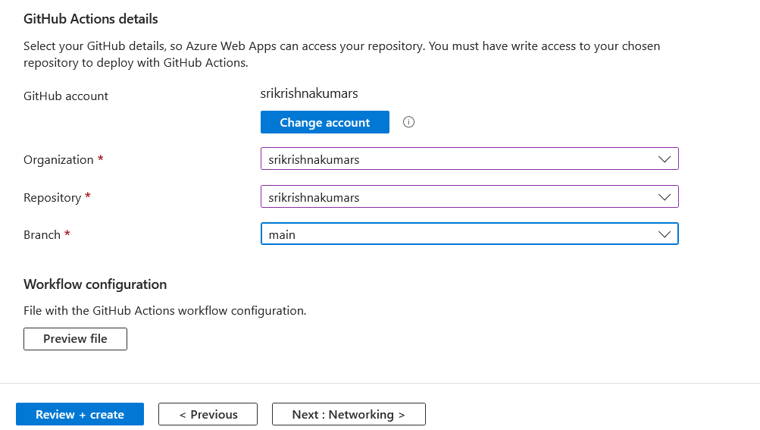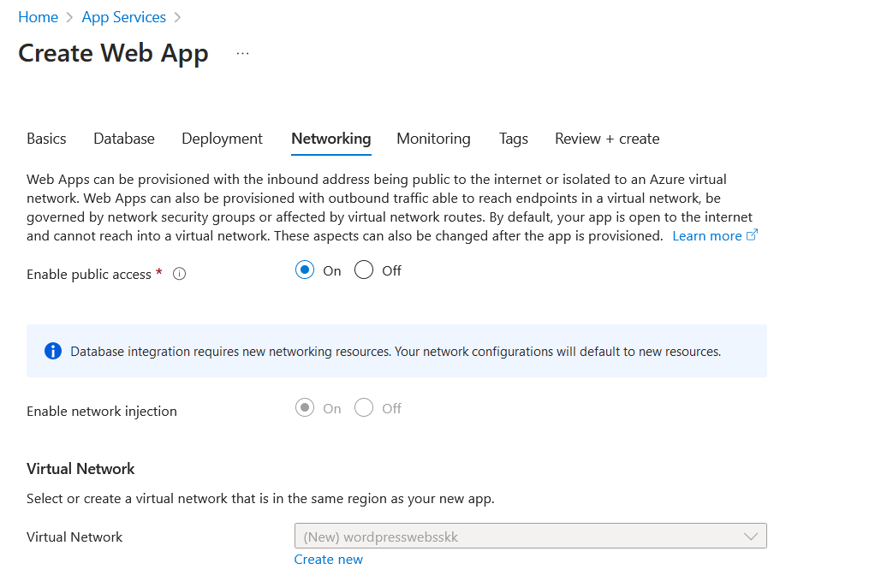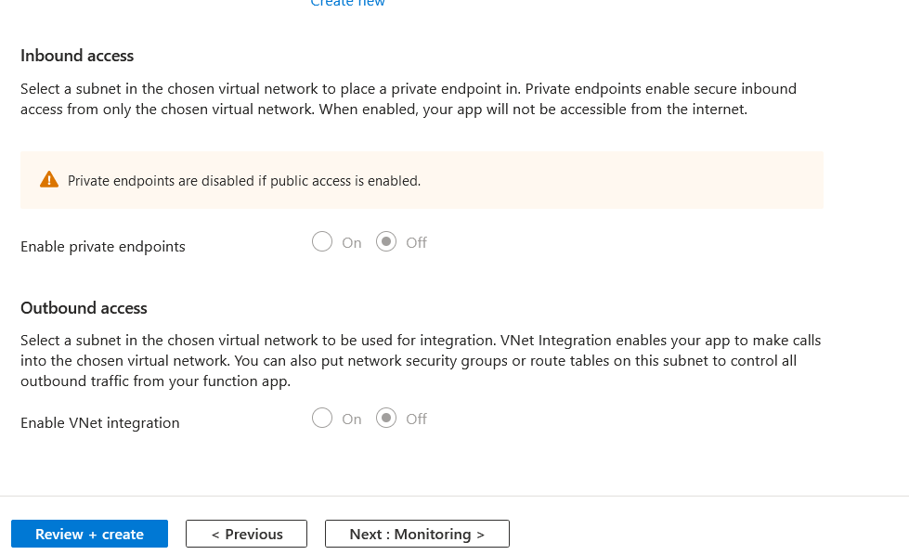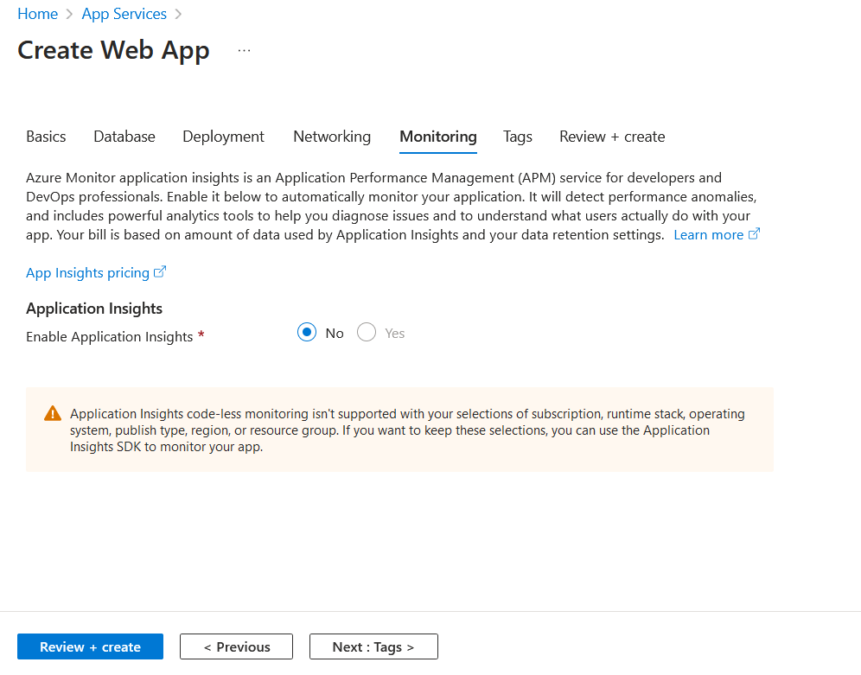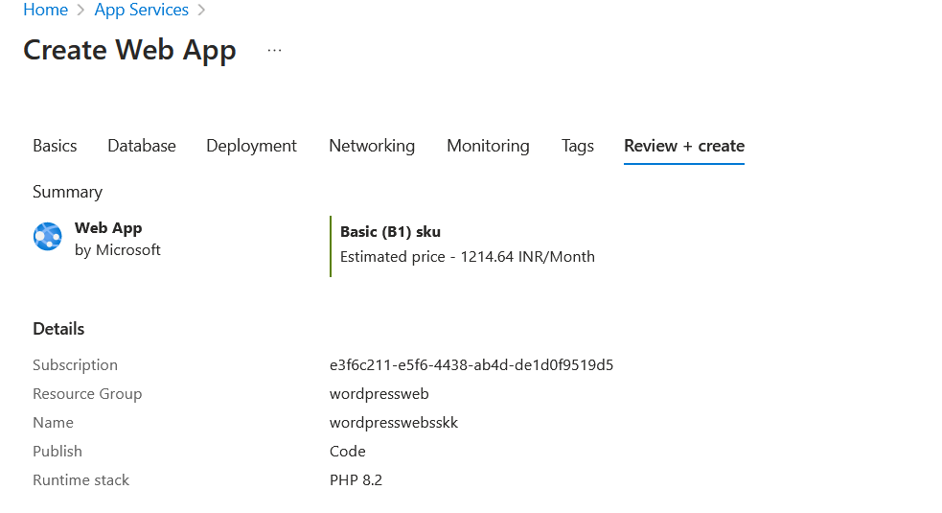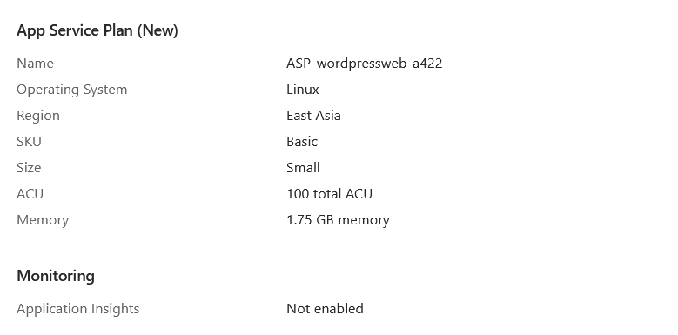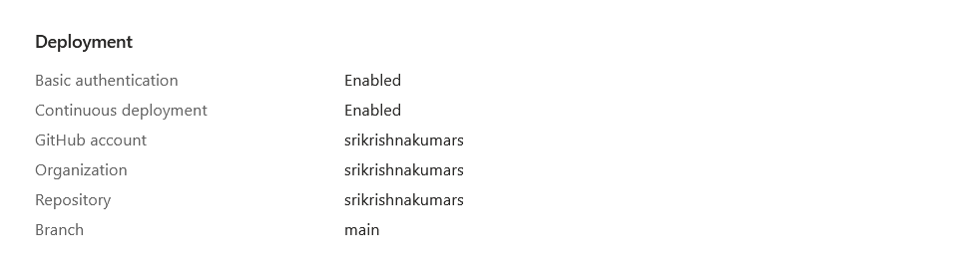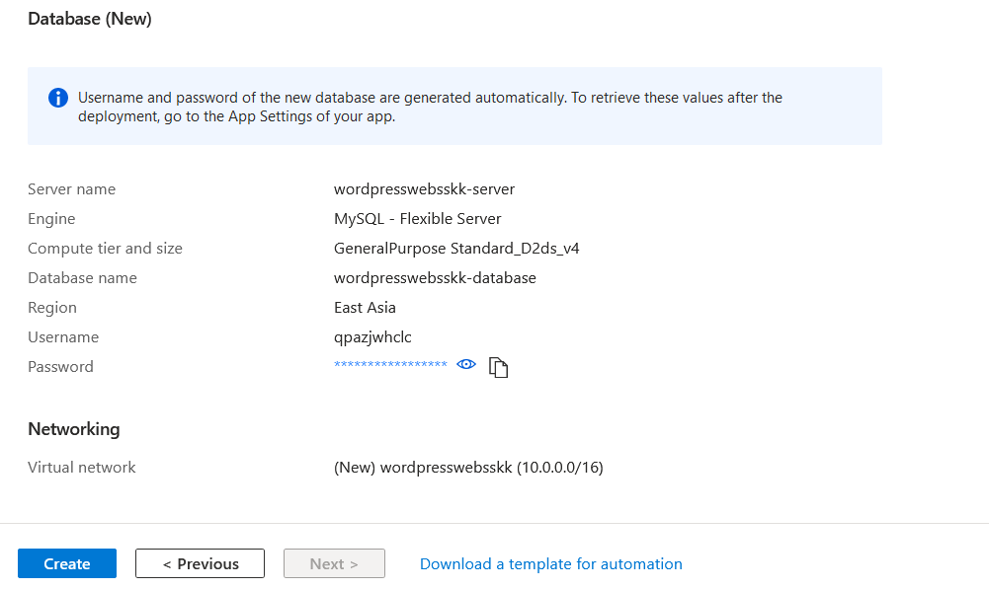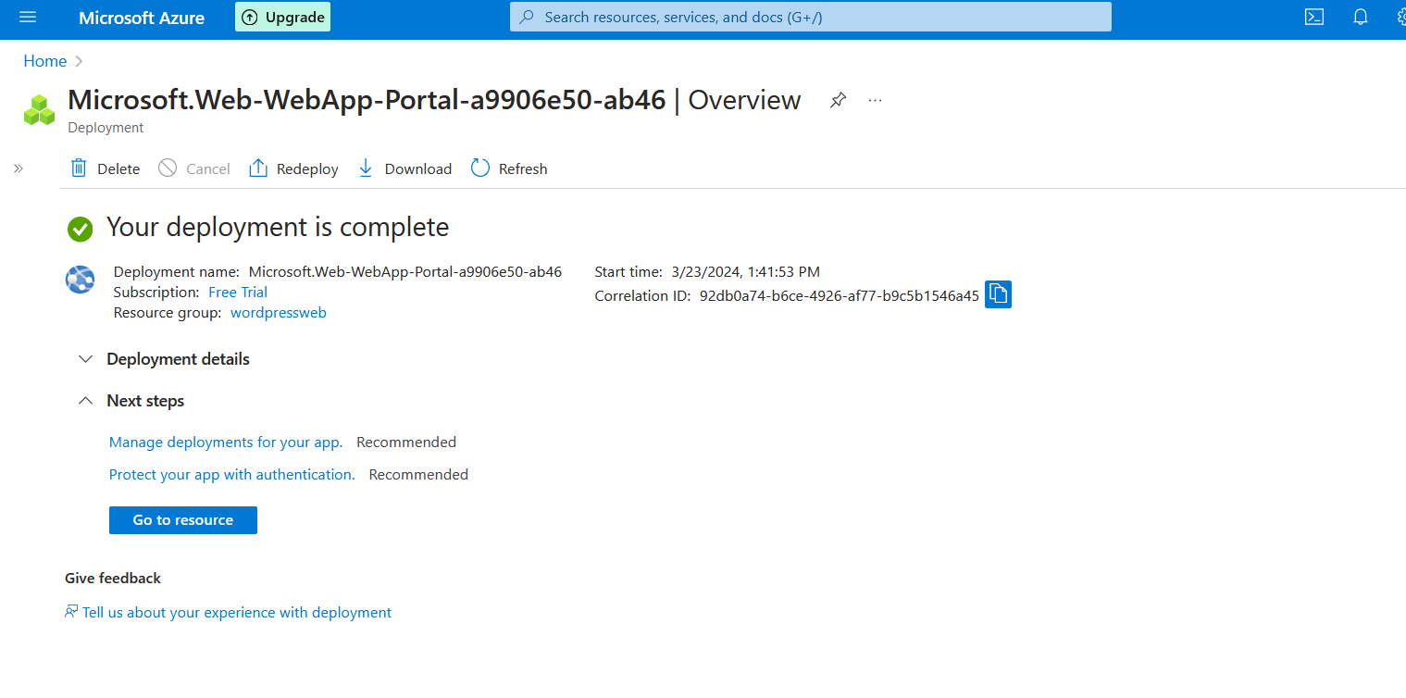

* + - Fill in the required details such as resource group, app name, and choose the appropriate pricing tier.
    - Follow the wizard to complete the setup of the web server.
  + **Azure Application Server:**
    - Depending on your requirements, you can set up a virtual machine or use Azure App Services to host your application.
    - If using a virtual machine, navigate to "Create a resource" > "Compute" > "Virtual Machine" and follow the wizard.
    - If using Azure App Services, you can create another Web App instance.
  + **Azure Database Server (MySQL or Azure Database for MySQL):**
    - Navigate to "Create a resource" > "Databases" > "Azure Database for MySQL".
    - Fill in the required details such as server name, admin credentials, resource group, and choose the appropriate pricing tier.
    - Follow the wizard to complete the setup of the database server.

1. **WordPress Installation and Configuration:**
   * **SSH into the Web Server:**
     + Use SSH client like PuTTY to connect to the Azure Web Server.

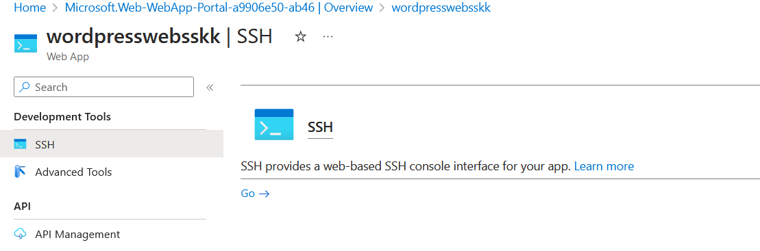 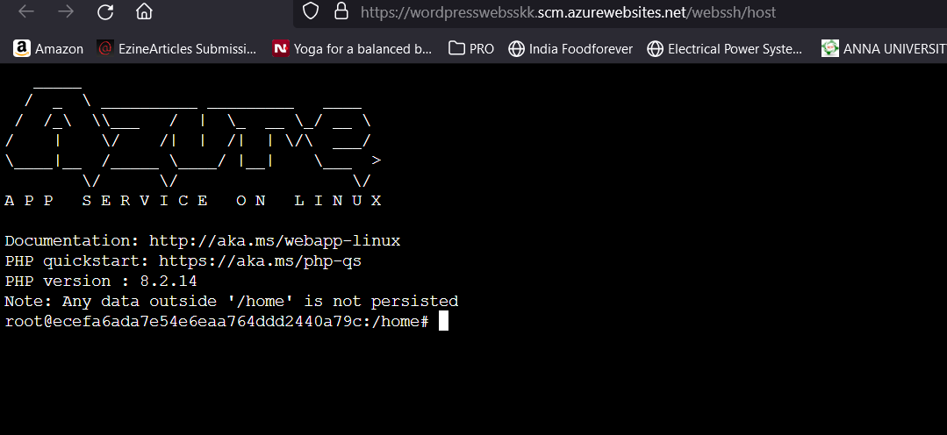

* + **Install WordPress:**
    - Download the latest WordPress package:

arduino

• wget -c http://wordpress.org/latest.tar.gz 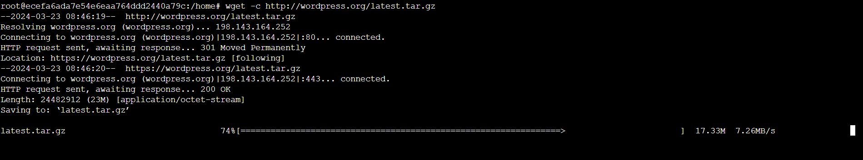

• Extract the downloaded package:

• tar -xzvf latest.tar.gz 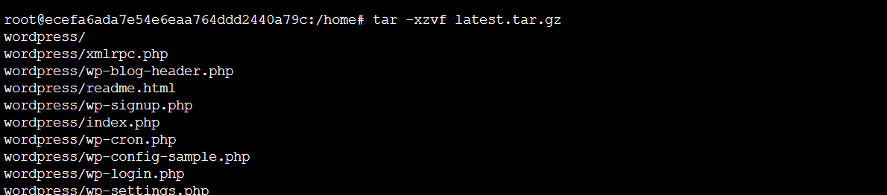 

• Move WordPress files to the web server's root directory:

bash

• sudo mv wordpress/* /var/www/html/ 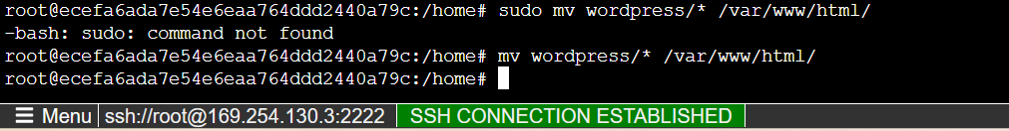

• Set appropriate permissions:

bash

* •
* sudo chown -R www-data:www-data /var/www/html/
* sudo chmod -R 755 /var/www/html/

• **Configure WordPress to use Azure Database Server:**

* Edit WordPress configuration file wp-config.php and provide the database connection details:

sql

* + - define('DB_NAME', 'your_database_name');
    - define('DB_USER', 'your_database_username');
    - define('DB_PASSWORD', 'your_database_password');
    - define('DB_HOST', 'your_database_server_address');
  + **Set up necessary themes and plugins:**
    - Access the WordPress admin dashboard and install themes and plugins as needed.

1. **Data Backup and Restore:**
   * **Implement Backup Scripts or Azure Backup Services:**
     + You can use built-in Azure Backup services or implement custom scripts to backup your WordPress database.
     + For Azure Backup services, navigate to your database server resource and configure backup settings.
   * **Set up Automated Backup Schedules:**
     + Configure automated backup schedules either through Azure Backup services or using cron jobs if using custom scripts.
   * **Test Backup and Restore Process:**
     + Regularly test the backup and restore process to ensure data integrity and availability.
     + You can test by simulating a data loss scenario and restoring data from backups.